# **HW9_Spotify Tracks Dataset**

# **312553024 江尚軒**

## Word cloud

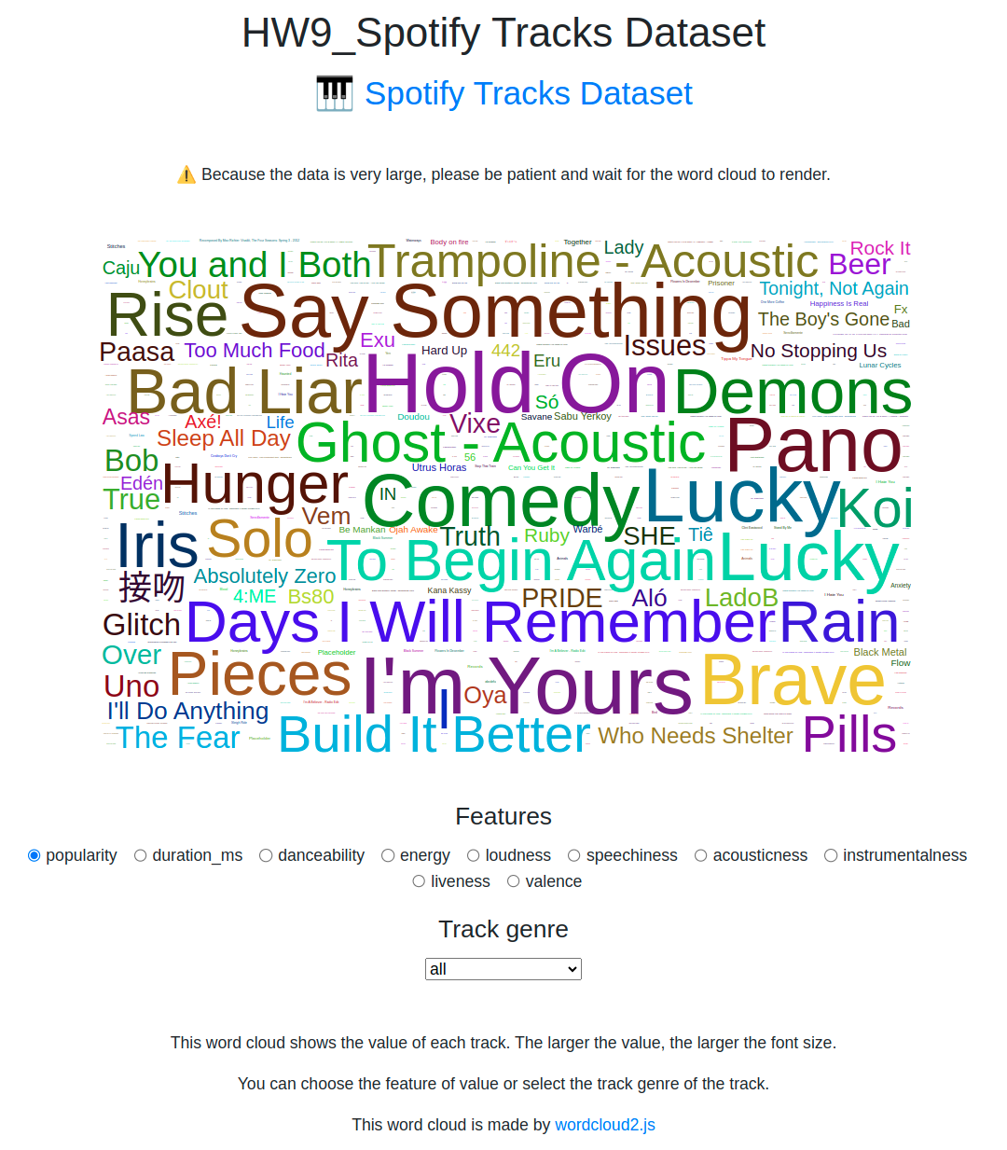

I opted for a word cloud to visualize the Spotify Tracks Dataset, as it contains both track names and numerous numerical values. The word cloud is well-suited for presenting this type of data, providing a visually engaging representation.

This word cloud shows the value of each track. The larger the value, the larger the font size.

The color of the track is randomized every time.

When you hover on the track name, you can see the exact value of this track.

You can choose the feature of value by radio or select the track genre of the track by selector.

This word cloud is made by [wordcloud2.js](https://github.com/timdream/wordcloud2.js).

## Examples

### Example 1

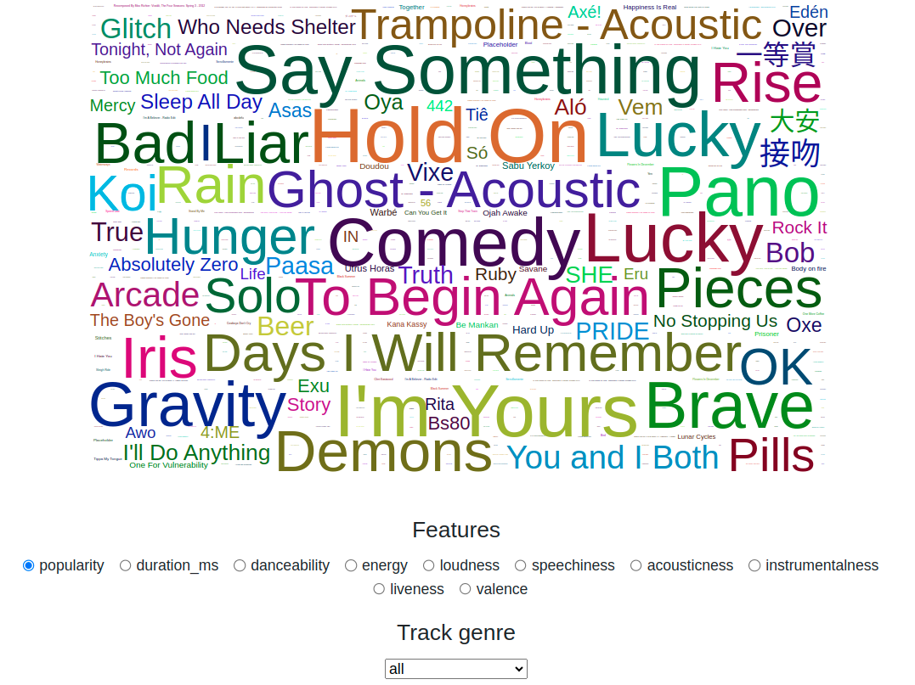

We can find that the top 3 popular songs in all of the tracks are Hold On, I'm Yours and Say Something.

### Example 2

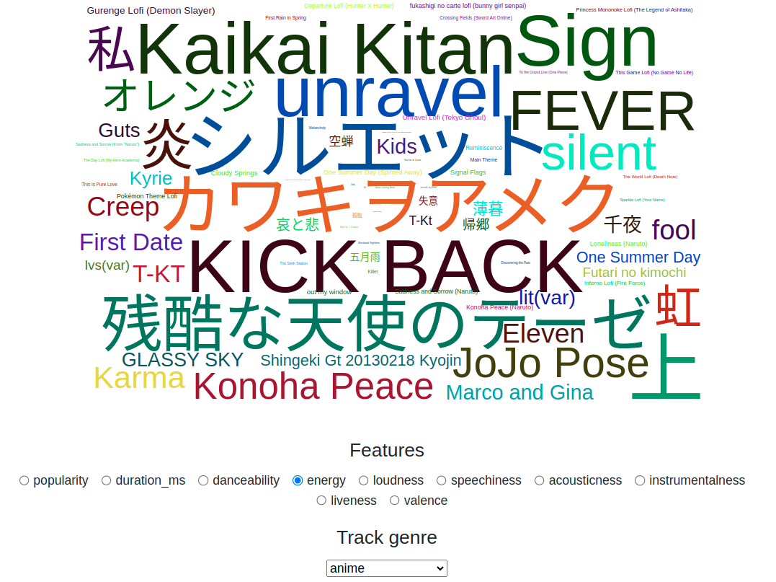

We can see that the top 3 energy tracks in anime songs are シルエット, カワキヲアメク, and KICK BACK.

### Example 3

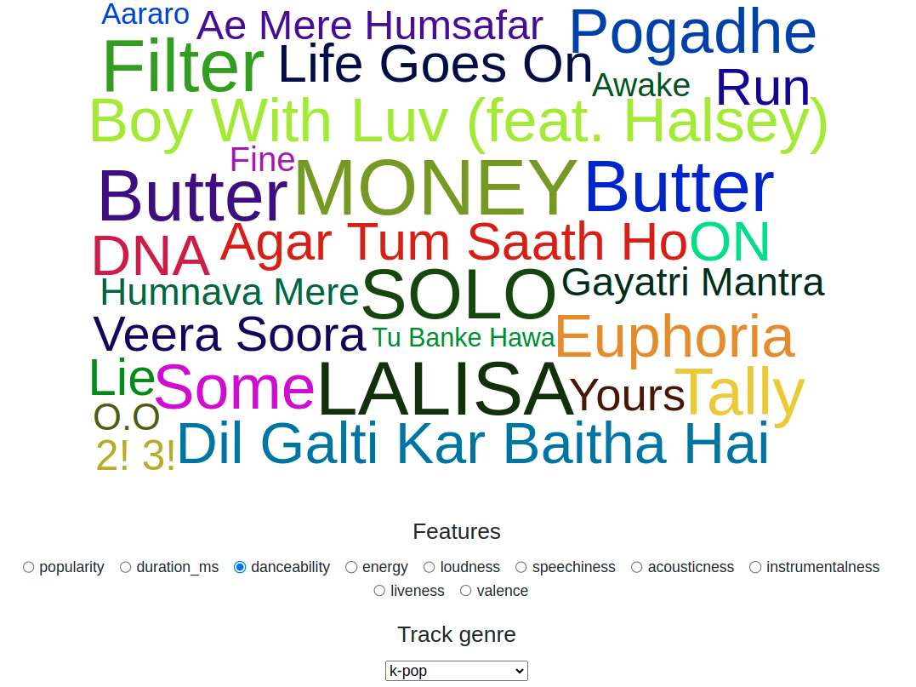

We can see that the top 3 danceability tracks in K-pop songs are MONEY, LALISA, and SOLO.

### Interesting finds

I discovered that the songs in the dataset are somewhat outdated. I believe this is due to the dataset being last updated a year ago, resulting in the exclusion of more recent songs. This observation also indicates that the popularity of music has changed rapidly.